MONETARY THEORY AND POLICY: TAKEHOME ASSIGNMENT 3

1. The New Keynesian Supply Side
In this exercise you will work out the supply side of the New Keynesian model. The economy is populated by a large number N of firms producing a differentiated good. Each firm i produces a variety of the good, label it i as well, according to a linear production function: Y (i) = AN(i) (1)
where Y (i) is the output of variety i, N (i) is the labor it uses and A is a common productivity term. These producers are monopolistically competitive, hence they take demand for their variety as given and choose the optimal price level P (i). Varieties are imperfect substitutes in the preferences of the consumer.

Question 1
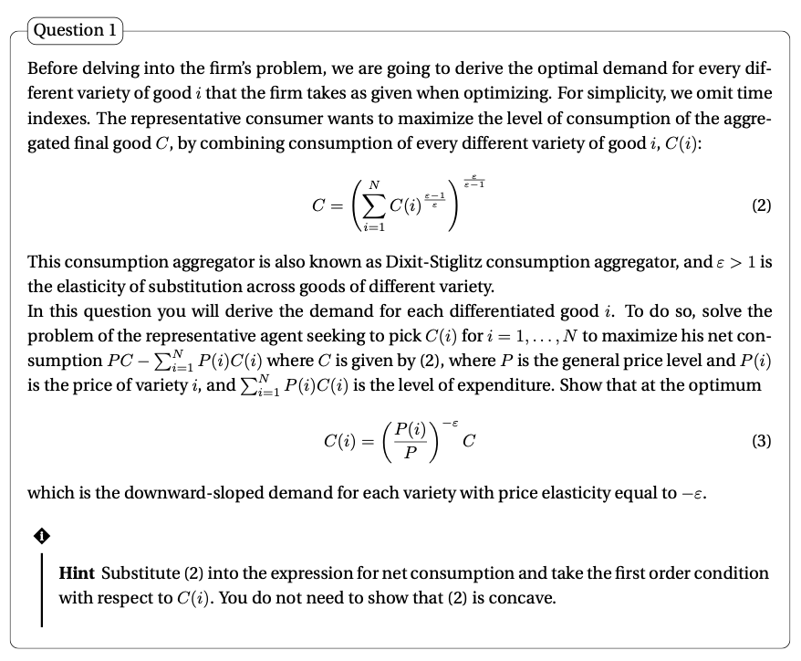
We maximize net consumption by putting $C= {\left(\sum_{i=1}^{N}{{C(i)}^{\frac{ε-1}{ε}}}\right)}^{\frac{ε-1}{ε}}$ into PC - $\sum_{i=1}^{N}{P\left(i\right)C(i)}$
Hence we get: P ${\left(\sum_{i=1}^{N}{{C(i)}^{\frac{ε-1}{ε}}}\right)}^{\frac{ε-1}{ε}}$ - $\sum_{i=1}^{N}{P\left(i\right)C(i)}$
We take FOC wrt C(i) : P $\frac{ε}{ε-1 } {\left(\sum_{i=1}^{N}{{C(i)}^{\frac{ε-1}{ε}}}\right)}^{\frac{ε}{ε-1}-1} \frac{ε-1}{ε} {C_{i}}^{\frac{ε-1}{ε}-1}$ – P(i)

P${\left(\sum_{i=1}^{N}{{C(i)}^{\frac{ε-1}{ε}}}\right)}^{\frac{ε}{ε-1}-1 } {C_{i}}^{\frac{ε-1}{ε}-1}$ – P(i) P${\left(\sum_{i=1}^{N}{{C(i)}^{\frac{ε-1}{ε}}}\right)}^{\frac{ε}{ε-1}-\frac{ε- 1}{ε- 1} } {C_{i}}^{\frac{ε-1}{ε}-\frac{ε}{ε}}$ – P(i)
P${\left(\sum_{i=1}^{N}{{C(i)}^{\frac{ε-1}{ε}}}\right)}^{\frac{1}{ε-1} } {C_{i}}^{\frac{-1}{ε}}$ – P(i) P${\left(\sum_{i=1}^{N}{{C(i)}^{\frac{1}{ε}}}\right)}^{ } {C_{i}}^{\frac{-1}{ε}}$ – P(i)

${\left(C^{\frac{1}{ε}}\right)}^{ } {C_{i}}^{\frac{-1}{ε}}$ = $\frac{P(i)}{P}$ $C^{ } C_{i}^{-1}$= ${\left(\frac{P(i)}{P}\right)}^{ε}$

$\frac{1}{C_{i}}$= ${\left(\frac{P(i)}{P}\right)}^{ε}$ $\frac{1}{C}$

$C_{i}= {\left(\frac{P(i)}{P}\right)}^{-ε}C$

The consumption of good Ci will be clearly affected by the average price for all products, the price of the good considered, and the elasticity of consumers. Elasticity will determine how reactive consumers are to differences in prices. The more the consumers are reactive the more a low Pi price relative to P will increase demand.

Question 2
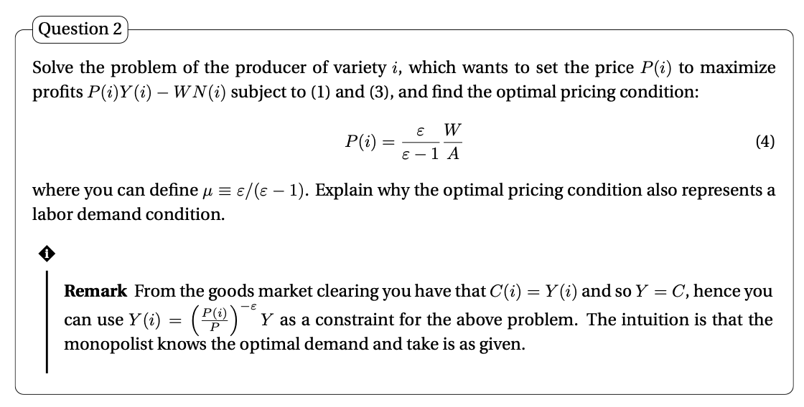

We can rewrite $C_{i}= {\left(\frac{P(i)}{P}\right)}^{-ε}C$ as $Y\left(i\right)= {\left(\frac{P(i)}{P}\right)}^{- ε}$Y

Max. [1] P(i)Y (i) − WN(i) under [2] Y(i) = AN(i) and [3] $Y\left(i\right)= {\left(\frac{P(i)}{P}\right)}^{- ε}Y$

put 2 into 1: P(i)Y (i) − W$\frac{Y(i)}{A}$ [4]

put 3 into 4: P(i) ${\left(\frac{P(i)}{P}\right)}^{- ε}Y$ − W $\frac{1}{A} {\left(\frac{P(i)}{P}\right)}^{- ε}Y$ (P(i) - W $\frac{1}{A}$) ${\left(\frac{P(i)}{P}\right)}^{- ε}$ Y [5]

FOC of [5] wrt Pi: $- \frac{ ε- 1 }{{\left(\frac{P(i)}{P}\right)}^{ε}}$ Y - ε ${\left(\frac{P(i)}{P}\right)}^{-ε-1}\frac{1}{P} \frac{W}{A}$ Y

$- \left(ε-1\right){\left(\frac{P\left(i\right)}{P}\right)}^{-ε}Y$ - ε ${\left(\frac{P(i)}{P}\right)}^{-ε-1}\frac{1}{P} \frac{W}{A}$ Y $- \left(ε-1\right)$ - ε ${\left(\frac{P(i)}{P}\right)}^{-1}\frac{1}{P} \frac{W}{A}$ $- \left(ε-1\right)$ - ε $\frac{1}{P(i)} \frac{W}{A}$

$\frac{1}{P(i)}$ = $\left(\frac{ε-1}{ε}\right)$ $\frac{A}{W}$ $P\left(i\right)= \frac{ε}{ε - 1}\frac{W}{A}$ [6]

This pricing condition also represents a labor demand condition. The $\frac{W}{A}$ ratio ties the price to the labor cost. When a firm sets its optimal price, it automatically sets the amount of labor (considering a given productivity) required to produce a defined quantity of the good (up until the desired price is realized). Basically the amount of labor required is a result of the price-cost optimization.

Question 3
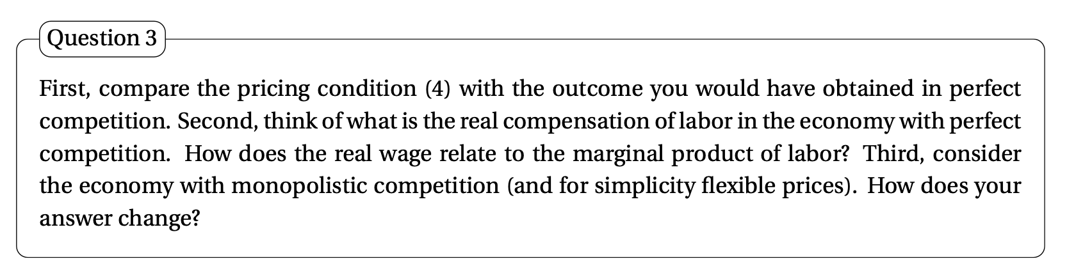

A. Perfect competition scenario
1. ε in perf comp is +inf Lerner index: $\frac{ε}{ε - 1}$ = 1 $P\left(i\right)= \frac{ε}{ε - 1}\frac{W}{A}$ [6] becomes: P(i) = $\frac{W}{A}$
Hence, in the perfect competition scenario the price charged is equal to the nominal marginal cost
2. If we now consider the real compensation of labor:
we take $P\left(i\right)= \frac{ε}{ε - 1}\frac{W}{A}$ [6] and we divide and multiply by Pt: $P\left(i\right)= \frac{ε}{ε - 1}\frac{\frac{W}{Pt}}{A} Pt$
If the markup is equal to 1 we deduce that $\frac{W}{Pt}=A \frac{Pi}{Pt}$
since the market is perfectly competitive Pi/Pt = 1, hence: $\frac{W}{Pt}=A$
real wage is equal to productivity

3. Since the production function is Y (i) = AN(i) (1)
Marginal product of labor (the derivative of Y wrt N) is equal to A.
hence, the higher the marginal product of labor the higher the real wage $\frac{W}{Pt}=A$

B. Monopolistically competitive market scenario:
1. ε is < +inf 1 Lerner Index: > 1 $P\left(i\right)> \frac{W}{A}$
Hence, in the monopolistically competitive market scenario the price charged is higher than the nominal marginal cost
2. If we now consider the real compensation of labor:
$P\left(i\right)= \frac{ε}{ε - 1}\frac{\frac{W}{Pt}}{A} Pt$ $P\left(i\right)= \frac{ε}{ε - 1} \frac{\frac{W}{Pt}}{A} Pt$ $\frac{W}{Pt}= \frac{ε}{ε - 1} \frac{AP(i)}{Pt}$ $\frac{W}{Pt}> \frac{AP(i)}{Pt}$

Since we assume all firms set flexible prices $\frac{W}{Pt}> A$
real wage is higher than productivity, and it is equal to: $\frac{W}{Pt}= \frac{ε}{ε - 1} A$

3. Since the production function is Y (i) = AN(i) (1)
the derivative of Y wrt N (marginal product of labor) is A.
Now:
$\frac{W}{Pt}= \frac{ε}{ε - 1} A$
Ceteris paribus (assuming markup is fixed), an increase in productivity will raise real wages

Question 4
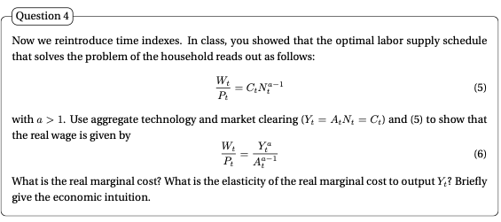

From: $\frac{W_{t}}{P_{t}} = C_{t} N_{t}^{α-1}$. If we substitute in $N_{t}= \frac{Y_{t}}{A_{t}}$ and we consider $Yt =C_{t}$ $\frac{W_{t}}{P_{t}} = Y_{t} {\left(\frac{Y_{t}}{A_{t}}\right)}^{α-1}$ $\frac{W_{t}}{P_{t}} = \frac{Y_{t}^{α}}{A_{t}^{α – 1}}$

The real marginal cost is equal to the real wage divided by productivity A, Hence:
MC = $\frac{Y_{t}^{α}}{A_{t}^{α }}$
If we now want to compute the elasticity of the real marginal cost to output, we compute $\frac{ Δ MC}{ Δ Y}$ * $\frac{Y}{MC}$

elasticity = $\frac{αY^{α-1}}{A_{t}^{α}}* \frac{Y}{\frac{Y_{t}^{α}}{A_{t}^{α }}}=α$

Hence, the elasticity of the real marginal cost to output is equal to a. As Output increases by 1% the real marginal cost will increase by a%. This is a typical result (increasing costs at the margin) in models where we do not have internal economics of scale.

Question 5
Combine the optimal conditions for labor demand and labor supply to write the firm’s optimal price as a function of the mark-up μ, aggregate output Yt, labor productivity At, and the aggregate price level Pt. Then, define the natural level of output Ytn and derive its expression. Briefly comment on the determinants of the natural level of output. Finally, use the expression of Ytn to obtain the firm’s optimal price as a function of Yt, Ytn, and Pt.

Demand: $P\left(i\right)= μ\frac{W}{A}$

Supply: $\frac{W_{t}}{P_{t}} = \frac{Y_{t}^{α}}{A_{t}^{α - 1}}$

We merge by substituting W from supply into demand:

$P_{t}\left(i\right)= μ\frac{1}{A} \frac{Y_{t}^{α}}{A_{t}^{α - 1}} P_{t }$ $P_{t}\left(i\right)= μ {\left(\frac{Y_{t}}{A_{t}}\right)}^{α}P_{t }$

If we assume all prices are flexible all firms will set prices: $P_{t}\left(i\right)= P_{t }$

Hence: $1= μ {\left(\frac{Y_{t}}{A_{t}}\right)}^{α}$ $Y_{t}^{n}= \frac{A_{t}}{μ^{\frac{1}{α}}}$
Τhe Natural level of output is level of output ($Y_{t}^{n}$) arising when prices are flexible (firms can quickly adjust their prices).
It is determined by
(i) technology At : the higher the technology level the higher workers’ productivity, hence the higher the aggregate level of output
and (ii) monopolistic competition in good markets μ: the lower the markup the more competitive the market thus the higher the aggregate level of output

if we now want the firm’s optimal price as a function of Yt, Ytn, and Pt, we write:
$P_{t}(i)=μ {\left(\frac{Y_{t}}{A_{t}}\right)}^{α}P_{t }=({\frac{{ Y}_{t }}{\frac{{ A}_{t }}{μ^{\frac{1}{α}}} })}^{α}P_{t}=({\frac{Y_{t}}{Y_{t}^{n}})}^{α} P_{t}$

Question 6
Assume that a fraction s ∈ (0, 1) of firms has sticky prices, whereas the remaining (1 − s) fraction sets its price flexibly. Write the last pricing condition you derived in the previous question in loglinear terms. Then, characterize the loglinear price set by flexible and sticky price firms. For sticky price firms assume for simplicity $y_{t}^{n,ε}= y_{t}^{ε}$ Finally, aggregate those prices to derive the loglinear expression for the aggregate price level.

Now, if we take logs:
$\log{P_{t}\left(i\right)}=a\left(\log{Y_{t}-\log{Y_{t}^{n}}}\right)+\log{P_{t}} -→ P_{t}\left(i\right)=a\left(y_{t}- y_{t}^{n}\right)+ P_{t}$

If we assume there are two types of firms:
1. flexible price firms (1-s)
$p_{t}\left(i\right)$ = a$\left(y_{t}- y_{t}^{n}\right)+ p_{t}$
2. Sticky firms:
these firms’ prices are the result of yesterdays’ expectations:
$p_{t}\left(i\right)$ = a$\left(y_{t}^{e}- y_{t}^{n,e}\right)+ p_{t}^{e}$ given that $y_{t}^{n,ε}= y_{t}^{ε}$ $p_{t}\left(i\right)$ = $p_{t}^{e}$

I we now aggregate these results, we get: $p_{t}=sp_{t}^{e}+\left(1-s\right)[a(y_{t}-y_{t}^{n}$)+ $p_{t}]$

Hence: ${p_{t}=p}_{t}^{e}+[ \frac{\left(1-s\right)α}{s} ](y_{t}-y_{t}^{n}$)

Question 7
Derive the Phillips curve. Then, explain how a deviation of inflation from expected inflation causes a deviation of output from its natural level, and provide an intuition for this result.

${p_{t}=p}_{t}^{e}+[ \frac{\left(1-s\right)a}{s} ](y_{t}-y_{t}^{n}$), where we can call $\frac{1}{α}$ = $[ \frac{\left(1-s\right)a}{s} ]$

Hence, we write the Phillips curve:

$p= p^{e}+[ \frac{1}{α} ](y- y^{n}$),

recall the variables are in log, if we now subtract $p_{-1}$ from both sides

$p-p_{-1}= p^{e}- p_{-1}+[ \frac{1}{α} ](y- y^{n}$),

And now we can rewrite the difference in prices as inflation:
$π = π^{ε}+[ \frac{1}{α} ](y- y^{n}$)

We add ν to represent exogenous events:
$π = π^{ε}+[ \frac{1}{α} ](y- y^{n}$) + ν

or we can also write:

$π = π^{ε}+λx$ + ν
where λ = $\frac{1}{α}$ and x = $(y- y^{n}$)

According to this equation, deviation of output yt from the natural level ytn are related to deviation of the price level pt from the expected price level pte. As we can see from the formula higher than expected inflation means a greater output gap.
Intuitively: if the actual inflation rate is higher than the expected one some firms(sticky firms) are stuck with lower prices than optimal; these firms face higher demand for their products than the firms using flexible prices; sticky firms hence raise their production to meet the higher demand and aggregate output rises above the natural level.

The higher the number of sticky firms the higher the effect of inflation on the output gap and, consequently the higher the reduction in unemployment. Eventually, when all prices will be adjusted upwards, demand will be back to the original level.

If all firms are flexible the price increase is immediately internalized, production is reduced and no gap, no employment is created, there is no excess demand. Inflation raises immediately. This would mean that monetary policy works perfectly to raise inflation without altering output.

In summary:
The more sticky firm we have the greater the effect of a price increase to the output gap
Vice versa: the more sticky firm we have the smaller the effect of an output increase to prices

Let’s define an example. Consider the equation: $P_{t}- P_{t}^{e}=[ \frac{\left(1-s\right)a}{s} ](y_{t}-y_{t}^{n}$),

A. low proportion of sticky firms
If s = 0.1 $[ \frac{\left(1-s\right)a}{s} ]$ = 9a
Dp = 9a Dx
if Dx up by 1% Dp up by 9a% high effect of output increase to inflation
flexible firms will immediately adjust prices after demand shocks high effect of inflation in the SR

however Dx = Dp / 9a
an increase in prices will determine a weak effect on demand, being the firms flexible they will , and will immediately adjust their prices, hence avoiding any significant increase in demand

B. high proportion of sticky firms
If s = 0.9 $[ \frac{\left(1-s\right)a}{s} ]$ = 0.11a
Dp = 0.11a Dx
if Dx up by 1% Dp up by 0.11a%
sticky firms are very slow at adjusting prices after demand shocks low effect on inflation in the SR
however Dx = Dp / 0.11a
an increase in prices will determine a strong effect on demand, being the firms sticky they cannot raise their prices, and will receive an higher than expected demand

